Let x be the factorial/exponent whose leading M digits are to be find

Let us consider that x can be written as 10 y, where y is a decimal number.

Let

x=10y

Taking log10 both sides

log10(x) = y

after calculating value of y-

y will be of decimal type: abc.pqr

number before decimal: abc (integral part of y (floor(y)))

number after decimal: pqr (fractional part of y (y-floor(y)))

where abc will tell the number of digits in x and pqr will give the digits in x

**No. of digits in x** = abc+1 (Refer this in youtube: Logarithms - Finding the number of digits in a^b | Logs | Don't Memorise)

**To Find first M digits in x:**

firstMdigits = pow(10,pqr)*pow(10,M-1)

Example:

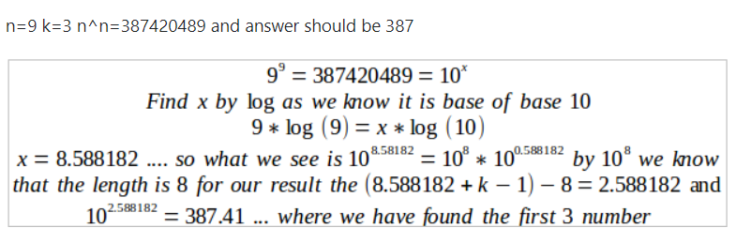

For **exponents**: x = ab

y = log10(ab) = b * log10(a)

For **factorial**: x = n!

y = log10(n!) = log10( n * (n-1) * (n-2) * …..* 3 * 2 * 1 )

= log10 (n) + log10(n-1) + log10 (n-2) +….+ log10 (3) + log10(2) + log10 (1)

(can find using loop from 1 to n)